New Approach to Road Construction in Oil-Producing Regions of Western Siberia
V Y Piirainen¹, Y Estrin^{2,3}

¹Saint Petersburg Mining University, 2, 21st Line, St Petersburg, 199106, Russia
² Monash University, Building 19, Clayton Campus, Wellington Road, Clayton, VIC 3800 Australia
³ National University of Science and Technology «MISiS», Moscow, Russia

E-mail: piraynen@gmail.com

Abstract. This article presents, as a polemic exercise, a new approach to road construction in marshland areas of oil and gas producing regions of Western Siberia. The approach is based on the use of novel modular elements that can be assembled into an integral structure by means of topological interlocking. The use of modern superlight concrete in conjunction with the new design systems based on the modular principle opens up new avenues to solving problems of road construction in regions with unstable, boggy soils.
- Introduction
It is well-known that 10% of the territory of Russia are marshlands with a total area of about 1.4 million km². It is this area that yields the major part of oil and gas produced in Far North and Western Siberia. The unstable, boggy soils in these regions make it necessary to construct oil rigs using roadbed filling and sealing of communication roads. Commonly, soil, sand and gravel are utilised for roadbed filling. Their supply is extremely expensive, which results in a high cost of oil and gas production. It has been estimated that the cost of road construction in these regions is 8-10 times higher than that in the central regions of the country.
The condition of the soil determines the number of wells in an oil rig and the spacing between them. Based on the number of oil wells, infrastructure construction for an oil rig is done. This includes sludge containers and reservoirs for storage of drilling fluids and petroleum, oil, and lubricants (POL).
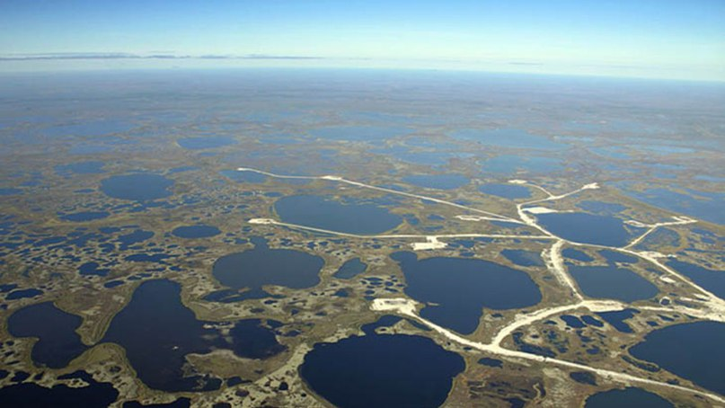
Figure 1. Oil rigs in Western Siberia (Source: http:/cs628619.vk.me).

Obviously, oil production in marshland regions is hampered by difficulties with transportation to and from the oil rigs (Figs. 1, 2). This calls for a search for ways to reduce the cost of construction and maintenance of roads to oil wells by optimising the efficacy of the supporting infrastructure.
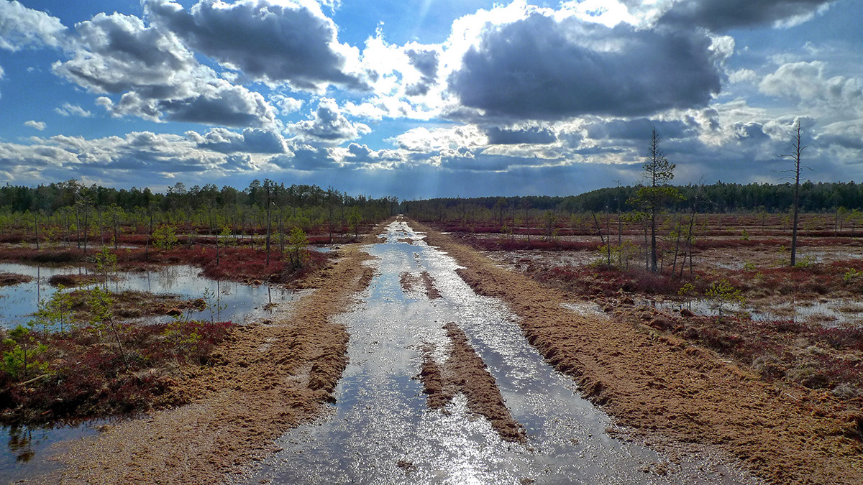
Figure 2. A typical condition of roads in Western Siberia in spring and summer (Source: http://img-b.photosigh.ru).

One possible solution is construction of so called free floating roads from segmented light concrete by employing a stepwise assembly technology and making use of the topological interlocking concept. Currently, such a technology is under development, with a view to be applied to construction of maritime and coastal protection structures [2, 3]. It is believed that this technology can also be considered for use in oil producing regions, including continental shelfs.
- Discussion
Relatively recently, a new term, ‘archimats’, has emerged in the vocabulary of materials scientists. It stands for materials with an engineered inner architecture at a length scale larger than the microstructural one. Topological interlocking materials consisting of small blocks assembled to a macrostructure fall in this category [2]. The notion of topological interlocking was coined by a group of Australian researchers [8-10] who developed new principles of shape design ideally suited for creating hybrid materials in which dissimilar constituents can be mixed within an integral assembly in any proportion. Building on this research, further studies are being conducted under a grant from the government of the Russian Federation that enabled the creation of a specialised Laboratory for Hybrid Nanostructured Materials at the National University of Science and Technology “MISIS”, which is headed by one of the authors of this paper. Based on these investigations, applications and practical implementations of the results in real economy sectors, including industrial and civil engineering, is being actively pursued.
It is timely to explain the specifics of topological interlocking (sometimes referred to as ‘self-wedging’). As reported earlier [10], an important distinction of the new class of materials and structures manufactured from them is their non-monolithic nature and a segmented structure consisting of separate blocks with a specific shape and special mutual arrangement. A characteristic example of such geometry are the so called osteomorphic blocks whose interlocking ability owes to their concavo-convex contact surfaces (Fig. 3). This geometry makes it impossible to remove any of the building blocks from the structure once it is assembled. Due to the tesselated pattern of the material, its resistance to failure is enhanced. In a way, the self-wedging of the individual elements of the assembly is akin to the assembly of arches and domes from bricks with cone-shaped surfaces, the difference being the self-wedging of osteomorphic blocks in all directions.
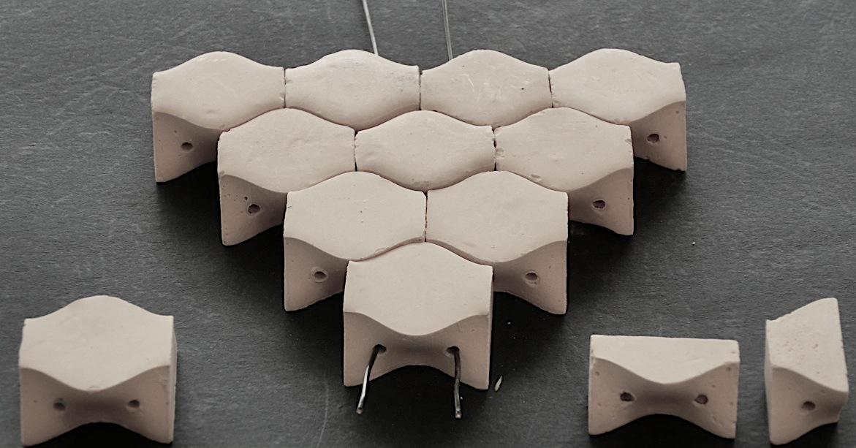
Figure 3. A Osteomorphic block assembly [6].

A remarkable property of segmented structures based on the topological interlocking design principle is that they retain their integrity under load even if part of the blocks have failed. This is obviously more important than the magnitude of their strength characteristics. This refers, in particular, to the survivability of a structure under service conditions despite damage it has accumulated. The primacy of this characteristic in construction engineering is indisputable, even though the methodology for defining it is more complex than the standard methods for determining conventional strength and performance characteristics.
These considerations are especially relevant in the context of construction and exploitation of roads under extreme conditions of the marshlands of Western Siberia where the development of the transportation is of a strategic importance for the government.
Having in mind that Western Siberia is not just a source of carbohydrates (which can be depleted in a foreseeable future), but above all is a sheer inexhaustible and replenishable source of thermal energy that can serve the mankind for millenia [1], one can conclude that developing these regions will be a sustained trend for many years to come. In this light, establishing a viable transportation system is a most important stage of the long-term program of development of Siberia.
According to a conservative estimate, the construction of one kilometre of a two-track road with a sealed surface in the West-Siberian marshlands comes at a cost of no less than 150 million roubles, roughly equivalent to $3 million. Building a pile-supported motorway would be even more costly. As an example, the expenditures for the construction of 48 km of the Adler-Krasnaya Polyana motorway amounted to 227 billion Roubles, or about $150 million per one kilometre [5]. It goes without saying that at such a cost development of these territories is not viable. What is needed today are breakthrough solutions that are significantly less expensive and can be implemented in a more speedy way.
The aim of this paper is to introduce a new concept for road construction making use of light building materials in conjunction with stepwise assembly of topologically interlocked osteomorphic blocks. It is suggested to use foamed concrete as a basis for such light materials. Modular osteomorphic blocks with the concavo-convex surfaces (Fig. 3) can be manufactured immediately at the construction site. Assembly of blocks to an integral structure of the road surface with topological interlocking of the blocks can be done on a water-proof rubbery substrate. The road surface produced in this way can subsequently be infiltrated with a rubber-like substance to make it fully water-proof.
Preliminary conclusions about the efficacy of such a system and the viability of the engineering solution proposed can be drawn from the results of a study of sandwich panels with a core segmented into osteomorphic blocks [6]. A comparison of the results of investigations of monolithic and segmented materials (Figs. 4 and 5), which can be regarded as laboratory analogues of a ‘road surface’, speak in favour of the latter unequivocally. It suffices to consider the tolerance of the segmented plate of Fig. 6 to local damage to have a convincing proof for that. The mentioned infiltration of the assembly with a rubber-like substance for water-proofing offers a number of further advantages with regard to enhancing the load bearing capacity and the crack resistance of the assembly [13].
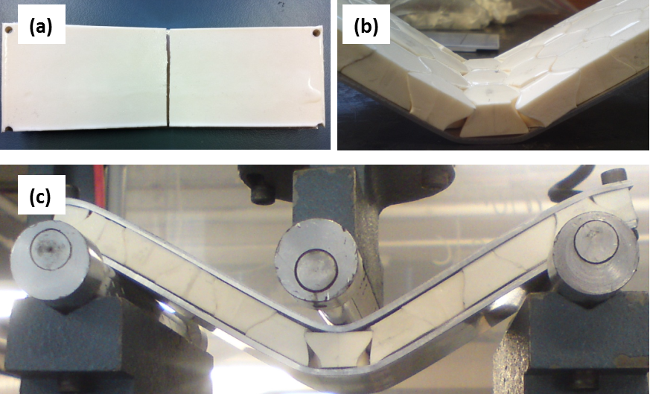
Figure 4. Deformation of plates under three-point bending: а – monolithic plate; b – plate assembled from osteomorphic blocks; c – sandwich panel with a core assembled from interlocked blocks.

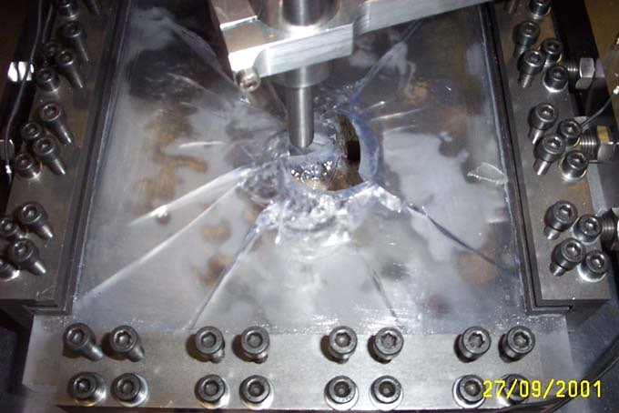
a b
Figure 5. Failure under point loading: a – of a massive plate; b – of a planar assembly of interlocked osteomorphic blocks

The feasibility of on-site fabrication of foamed concrete blocks using mobile manufacturing facilities is beyond doubt. Equally realistic is the production of a water-proof road surface by infiltration of an assembly of blocks laid on a substrate in a stepwise fashion with a rubber-like material. One can easily envisage the resulting structure and the operation of the manufacturing equipment combining assembly of the blocks, infiltration, and paving.
- Conclusion
Although the development of modular segmented structures commenced relatively recently, they have already attracted the attention of foreign architects and builders who value the benefits and the potential of topological interlocking as an engineering approach to large scale construction [7, 11, 12]. Applying this concept to the realities of Western Siberia appears to be no less – and possibly even more – attractive.
Obviously, the considerations presented in this article need to be verified by modelling, approbation, and validation under laboratory conditions before real-scale field testing is conducted to finally evaluate the viability of the proposed solutions. The authors are confident, however, that effort and cost of such investigations will be worthwhile because of the undoubtedly promising potential of the topological interlocking method as applied to road construction in the oil producing regions of Western Siberia and to other areas of civil engineering.

The present work was initiated by Saint Petersburg Mining University and conducted in collaboration with the Laboratory of Hybrid Nanostructured Materials of NUST MISIS funded by the Ministry of Education and Science of the Russian Federation (grant №14.А12.31.0001). Funding support under the Increased Competitiveness Program of NUST MISIS (grant №К2-2016-062) is gratefully acknowledged.
References
- Adzhiev M N. 1978 Goryachaya zemlya Tyumeni (Hot earth of Tymen’) Vokrug sveta
12 12-16
- Zimina Т, Zykov D 2014 Arkhimaty oni zhe gibridy (Archimats, aka hybrids) Nauka I zhizn’
1 43-44
- Piirainen V Y, Estrin Y 2015 Proc. of the International Scientific-Practical Conference (20-21 May , Sochi) 294-301, ISBN 978-5-88702-541-4
- Piirainen V Y, Estrin Y 2017 Zapiski Gornogo Instituta (Mining Institute Journal)
123 2017 (in press)
- Trushin A A 2005 Pryamye investicii (Direct investment) 9 (41) 20-24.
- Molotnikov A, Gerbrand R, Bouaziz O, Estrin Y 2013 Advanced Engineering Materials 15 (8) 728-731
- Fallacara G, Calabria C 2016 About Building Stereotomy: Theory And Practice //In: G. Amoruso, Ed., Visual Computing and Emerging Geometrical Design Tools. IGI GLOBAL
ISBN: 9781522500292
- Dyskin A, Estrin Y, Kanel-Belov A J, Pasternak E 2001 Scripta Materialia 44 2689-2694
- Dyskin A, Estrin Y, Kanel-Belov A J, Pasternak E 2003 Philosophical Magazine Letters
Vol. 83, No. 3, 197 - 203
- Estrin Y, Dyskin A, Pasternak E 2011 Materials Science and Engineering 31 1189-1194
- Tessmann O, Becker M 2013 Extremely heavy and incredibly light Proceeding the 18thth International Conference on Computer-Aided Architectural Design Research in Asia
(CAADRIA 2013) 469-478
- Weizmann M, Amir O, Grobman Y J 2015 Emerging Experience in Past, Present and Future of Digital Architecture, Proceedings of the 20th International Conference of the Association for Computer-Aided Architectural Design Research in Asia (CAADRIA 2015), The Association for Computer-Aided Architectural Design Research in Asia (CAADRIA) Hong Kong
- Djumas L, Molotnikov A, Simon G P, Estrin Y 2016 Enhanced Mechanical Performance of Bio-Inspired Hybrid Structures Utilising Topological Interlocking Geometry Scientific Reports
6 Article number: 26706 (2016) doi:10.1038/srep26706

